Task 0: Explain what you are doing/ going to accomplish

This will be my purchase page which will reduce the stock of each food item.

Task 1: Sketch interface design

*Draft a rough design for the interface that allows the user to trigger functionality in task 1, while also annotating where the information in task 2 will be displayed. Create another sketch listing the interface widgets used to create the interface.*

Task 2: Identify any classes required

*Explain what the class will represent, plus listing what information will be stored in the class and any functions the class will have.*

Task 3: Identify information to be displayed

*What information will the interface need to display to the user?*

Whether there is any stock available. Once purchased will show whether the purchase was successful and a button to return to the purchase page.

Task 4: Identify user inputs

*What program functions can the user trigger through the interface?*

I will have a button which allows people to purchase items of food one at a time.

Task 5: Identify any constants or existing data if required

Task 6: Identify indexed data structures

Task 7: Determine what calculations are necessary

*Write out the calculations the program will have to compute.*

Minus one from comic stock every time they purchase something.

Task 8: Develop a modular structure for your program

*Describe any functions that the computer program will have, identifying any sub-functions where required.*

Purchase page contains code which takes one off the stock whenever something is purchased.

Task 9: Define the functions identified

*Describe the functions for both the main program and any classes in terms of input and/or output where required. You may choose to do this with flow charts or pseudo-code (not Python code!). Add in additional steps or explanations using sequential, conditional, iterative statements where required. Identify global and/or local variables.*

ROUTE purchase_page PASS item_id

VIEW purchase_page

PROGRAM purchase_page PASS item_id

item_id = int(item_id)

found_item = None

FOR item IN items

IF item.id IS item_id

SET item TO found_item

SET data TO Dictionary (SET item TO found_item)

Take 1 away from found_comic.stock

RETURN data

Task 10: Address any relevant implications such as usability, functionality, legal/ethical requirements.

My webpage has to be functional and usable as well as looking good. I have to make it obvious where my purchase button is. I also have to show how much stock is left and to show the price of each of my items. I also have to make it function properly with no issues.

I made my purchase and purchase success pages colour scheme the same as other school websites. I made each item be in different cards which contain information on the item. In each of these cards is also a button which can be used to purchase one of that item. This button stands out so it is easy for the user to see how to buy items.

Task 11: Document test cases for testing the program

*Document any testing that can be used to test your program. If any input is inputted using the keyboard, describe the expected input, plus any exceptional, boundary or invalid cases.*

Task 12: Refine the plan

*Note any modifications here when iterating through the development cycles.*

Changed my product page code in html to include a button that the user can press to purchase each item.

Added <p><br style = "line-height: 43 ;"></p> to my html code to break multiple lines and extend my div colour lower down my page.

Task 13: Document testing

*Show screenshots of your program working with descriptions of each image. These images should test the tests cases listed above.*

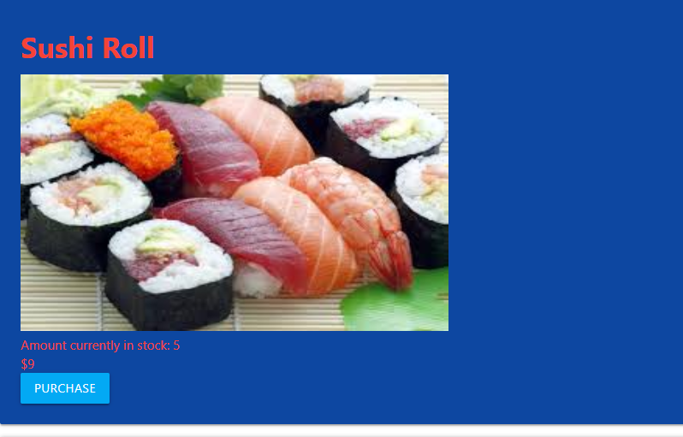

One of the cards containing information on my items.

Task 14: Evaluation

*How did your version turn out?*

My version 4.0 turned out perfectly. I successfully allowed the user to purchase stock of each of my items. This reduces the stock of each item to a minimum of 0. There were no major issues in my update. I was not happy with the way my page looked so I took a while to fix the design. My next step is to be able to restock my items stock.